**Donor Toolkit – Giving Tuesday 2024**

Thank you so much for fundraising for the Council for Exceptional Children this Giving Tuesday! Your donations go into five funds that help to support key areas of CEC’s work.

# **Where Do Your Donations Go?**

The ***Advocacy Fund*** provides support for initiatives to support ongoing policy and advocacy efforts of CEC. CEC advocates on behalf of children with exceptionalities 365 days a year. In doing so, CEC examines policy issues, develops appropriate responses to those issues, and influences local, state, provincial, and federal legislation.

* An example of the use of this fund by CEC: $1,000 supports CEC’s ability to send one advocate to the Special Education Leadership Summit in Washington, DC.

The ***Diversity Fund*** supports initiatives that promote diversity, equity, and inclusion in the field of special education. In alignment with its core values – especially inclusiveness – CEC is committed to embracing the diversity of beliefs and characteristics of its members, as well as individuals with whom its members’ work.

* An example of the use of this fund by CEC: $500 supports one winner of the Emerging Special Educators of Color Leadership Travel Award to CEC’s Convention.

The ***Fund for the Future*** is the operating endowment for CEC. No one can anticipate the future needs of CEC or future strategic initiatives that are needed to move the field forward. This fund helps CEC remain flexible and able to meet challenges that might arise.

The ***Rising Star Fund*** provides support for initiatives that attract, prepare and retain students and early career professionals. Your contribution to this fund will provide support for CEC initiatives that attract, prepare, and retain students and early career professionals.

* An example of the use of this fund by CEC: $500 supports 12 free student memberships to CEC.

The ***Yes I Can Fund*** ensures that CEC can continue to honor exceptional children and youth. Presented each year at the CEC Convention & Expo for over 40 years, the Yes I Can Awards recognize 12 outstanding students with exceptionalities in six categories: Academics, Arts, School & Community Activities, Self-Advocacy, Technology, and Transition.

* An example of the use of this fund by CEC: $1,000 supports one Yes I Can winner.

# **Start Your Fundraiser**

There are several ways for you to create a fundraiser this Giving Tuesday:

## **CauseVox**

CauseVox is CEC’s fundraising platform. You can donate directly to the platform or you can create your own fundraiser that your friends, family, and peers can donate to:

1. Sign up at <https://cec-giving-tuesday-2024.causevox.com/> by clicking “Join”
   1. If you already have an account with CauseVox, you can log-in.
2. Sign up to start a fundraiser by providing your first and last name, email, and create a password.

1. Create your personal fundraising page by providing:
   1. Display Name
   2. Profile Picture
   3. Title of the fundraiser – We suggest making it “[*First name*]’s 2024 Giving Tuesday Fundraiser”
   4. Stub – This will be the link your donors can use. It will appear as [https://cec-giving-tuesday-2024.causevox.com/p/[*stub-name*](https://cec-giving-tuesday-2024.causevox.com/p/%5bstub-name)]
   5. Your Fundraising Goal
   6. The End Date – We suggest setting this at the end of the week of Giving Tuesday (December 6 or 7)

1. Write your fundraising appeal. Make it personal; explain why you want to support CEC, what the mission means to you, and what is motivating you:

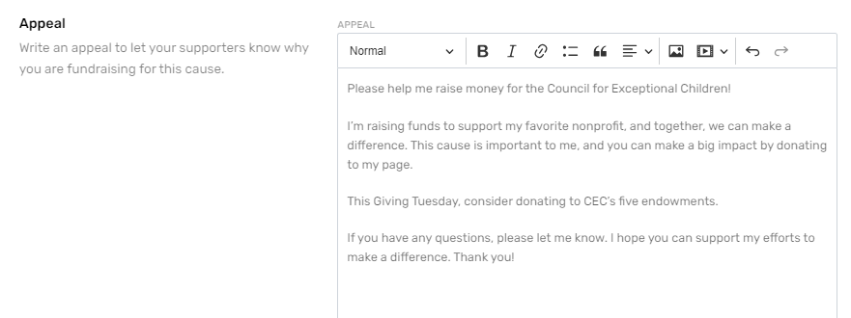

1. Spread the word! Share your fundraiser on your social media platforms, by email, text, or whatever communication method you utilize.
2. You can manage and edit your fundraiser from your account. Provide updates, view your donations, edit your goals, and create or join a team.

## **Facebook Fundraiser**

Facebook allows you to create a fundraiser for the Council for Exceptional Children and easily share it with your friends.

1. Go to the [Council for Exceptional Children’s Facebook profile](https://www.facebook.com/cechq) and select “Fundraisers”

1. Select “Raise money”

1. Create a fundraiser or create a fundraiser challenge
   1. Fundraisers allow you to raise money from your friends and followers. A fundraiser challenge ties funds to an activity, such as miles walked/run/biked, or a custom activity of your choosing.

1. For fundraisers, set your details, such as your funding goal, when your fundraiser will end, the title of your fundraiser and, why you are raising money. Make it personal; explain why you want to support CEC, what the mission means, and what motivates you. You can add your own personal cover photo or use the one provided.

1. For fundraising challenges, set your activity type and goal, then set your goal, the challenge dates and, what the challenge is about:

# **Promote Your Fundraiser**

## **Social Media**

* I’m giving back on #GivingTuesday by supporting the Council for Exceptional Children and its mission to cultivate, support, and empower education professionals who work with individuals with disabilities! Will you join me?
* On #GivingTuesday, I want to share my favorite organization, the Council for Exceptional Children, because they work to cultivate, support, and empower education professionals who work with individuals with disabilities. Learn more at exceptionalchildren.org.
* I’m proud to dedicate my #GivingTuesday to the Council for Exceptional Children. CEC champions the rights and needs of individuals with exceptionalities. Join me in their mission to create a more inclusive world for everyone!
* CEC is dedicated to advancing the rights, opportunities, and achievements of individuals with exceptionalities. Support their mission and donate this #GivingTuesday!
* Every child deserves the chance to shine. CEC works tirelessly to ensure individuals with exceptionalities have those opportunities. Donate to support CEC this #GivingTuesday.
* Why do I support the Council for Exceptional Children? I support CEC because [*write your personal reasons*]. Join me this #GivingTuesday in donating to CEC.

## **Email**

Dear [*XYZ*],

Giving Tuesday is dedicated to giving back to nonprofits after the rush of post-Thanksgiving shopping. This year, I’ve decided to support the [Council for Exceptional Children](https://exceptionalchildren.org/). CEC works to cultivate, support, and empower education professionals who work with individuals with disabilities by:

* Advocating for education professionals and for individuals with disabilities, and/or gifts and talents
* Advancing professional practice and scholarly research
* Promoting diversity, equity, inclusivity, and accessibility
* Building networks, partnerships, and communities

Donating to CEC allows them to continue working towards their mission and make the world more inclusive for all. I choose to support CEC this year because [*insert reasons here*]. Join me in supporting this amazing cause by donating to my fundraiser: [*insert link to fundraiser*].

Thank you so much for your time and generosity,

[*NAME*]

## **Graphics**

[Download the following graphics here.](https://drive.google.com/drive/folders/1fru2sIxVnl_SumTrQlKpCLmJY7-ZWhYQ?usp=share_link)

# **Tips + Best Practices**

* Make it personal. Your network wants to know why fundraising for CEC matters to you. Add your touch and let people know more about CEC’s meaning to you.
* Make it fun – add a fun touch to your fundraiser. If you raise $X by a certain time, post a funny video of you dancing, getting pied, or getting a bucket of water poured over your head, ala the ALS Ice Bucket Challenge.
* Thank your donors—Remember to thank those who donate to your fundraiser. Comment on their donation, send them a direct message, or even a card via snail mail.
* Offer a match – boost your donations by offering a match. You'll match every $X amount donated by a chosen percentage.
* Provide a gift – offer a gift to those who donate. This can be anything from baked goods, a postcard, a drawing, or something you can create.