2024 Fall Professional Development Fair Promotion Toolkit

*Updated 10.2.2024*

# Overview

Join us for CEC's Fall PD Fair! This online event features over 20 live 1-hour sessions with content from CEC, our Special Interest Divisions, the PROGRESS Center, the IRIS Center, and Lead IDEA. So step right up and pick the sessions you like best. All sessions will air live and be recorded for registrants to view later.

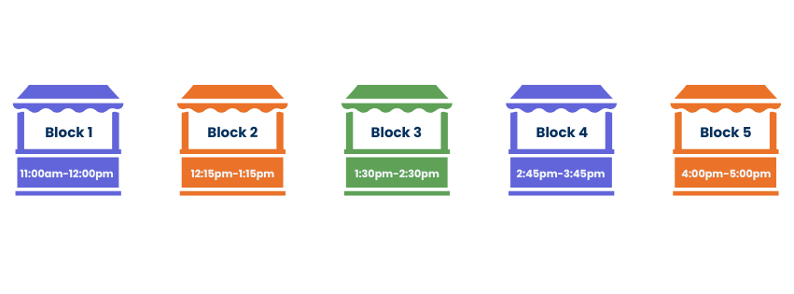

1. Select one (1) session in each time block when you register. That's five (5) sessions total worth 5 CEUs!
2. You'll receive Zoom Webinar access information for the live sessions (all times in Eastern) from the CEC PD team soon.
3. Within 5 business days after the live session, you'll receive access to the recording for 60 days.

[Here is an overview of all of the sessions offered in each time block.](https://exceptionalchildren.org/fallPDfair/schedule)

# Key Dates

* Registration closes: October 23, 2024, at 5 PM ET
* Event: October 24, 2024, 11:00 AM – 5:00 PM ET

# Links

* Event page: <https://exceptionalchildren.org/fallPDfair>
* Registration page: <https://exceptionalchildren.org/fallPDfair/registration>
* Session page: <https://exceptionalchildren.org/fallPDfair/schedule>

# Social Media Posts

* 🎪Step right up, folks! 🎪Don't miss the Fall PD Fair—packed with live, virtual sessions that will sharpen your skills and elevate your expertise. Whether you're a seasoned pro or just getting started, we've got something for YOU!
* Come one, come all, to CEC's Fall PD Fair! 🎪This online event features over 20 live 1-hour sessions with content from CEC, our Special Interest Divisions, the PROGRESS Center, the IRIS Center, and Lead IDEA.
* Have you registered for the Fall PD Fair? Join us on October 24 for a day packed with essential sessions tailored for special education professionals. Can’t attend live? No worries—register today, and you’ll get access to recordings of all the sessions you choose. Don’t miss out!
* Join us for CEC's Fall PD Fair! This online event features over 20 live 1-hour sessions with content from CEC, our Special Interest Divisions, the PROGRESS Center, the IRIS Center, and Lead IDEA. All sessions will air live and will be recorded for registrants to view later.

# Social Media Graphics

Share any of the graphics [found in this folder](https://cecsped.sharepoint.com/:f:/s/CECServer/EporNIQwIg5Fozsma1PTRcIBFdDg2jKfRVxi17gbqZUpbw?e=Hl3ceE) with the above social media posts.