Manitoba Council for Exceptional Children Presents
Conference 2022 (Virtual)
February 17 & 18, 2022

Featured Speakers:
Leyton Schnellert
Michelle Garcia Winner

To purchase tickets, click here:
https://www.eventbrite.ca/e/2022-manitoba-council-for-exceptional-children-virtual-conference-tickets-202581144657

For more information email: manitobacec@gmail.com

*ANNUAL AGM TO FOLLOW CONFERENCE ON FRIDAY*

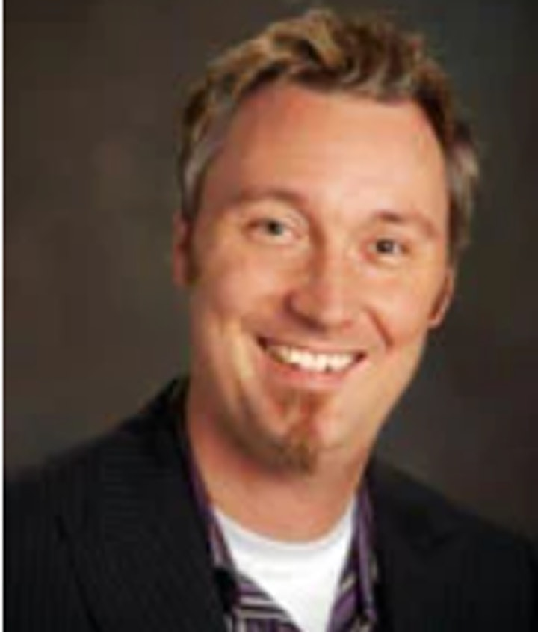

Leyton Schnellert

THURSDAY FEBRUARY 17th, 2022
9-12 ONLINE
12-1 LUNCH
1-3:30 ONLINE

Developing self-regulated learners

All students deserve to be self-regulating learners and feel ownership of their successes. In this session we’ll explore how to scaffold self-regulated learning (SRL) for all students in inclusive classrooms. We will consider how educators can establish safe and supportive learning environments that foster rich forms of learning and SRL; key guidelines educators can follow when building SRL-promoting practices; and how educators can design activities and tasks that create opportunities for rich forms of learning and self- regulation.

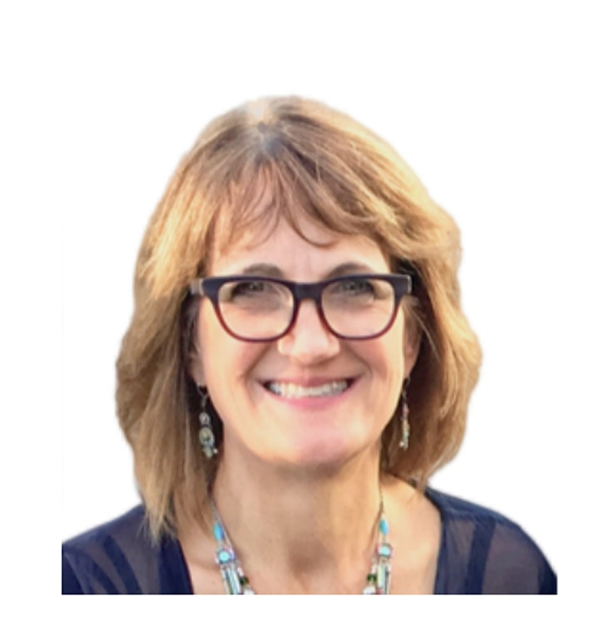
Michelle Garcia Winner

FRIDAY FEBRUARY 18th 2022
8:30 – 11:35 Welcome and Online Course
11:35 – 12:05 Live Q & A with Michelle
12:05 – 12:30 Lunch
12:30 – 3:30 Online Course
3:30 – 4:00 Live Q & A with Michelle

Assessing Social Competencies Using Social Thinking® Informal Dynamic Tasks

This session focuses on practical strategies to explore ways in which we can assess social competencies, also known as “soft skills,” that are foundational to building an array of social relationships, problem solving, and teamwork. The session uses client/student/patient videos to guide learning about assessment tasks and how different individuals may respond. This information is helpful to all interventionists working and living with individuals with social emotional learning challenges because it shows how to get inside their minds to better understand their learning strengths and challenges.

