Accessing the American Rescue Plan Act Partnership Webinars in the CEC Learning Library
The CEC Learning Library is where you can access webinar recordings, download Professional Development Hours certificates for webinars you’ve attended or viewed, and manage your own professional learning journey.
Here’s how to access the Learning Library and the webinars on the American Rescue Plan Act.

- If you know your CEC account information:
Head to https://cec.interactyx.com/loginoauth2.aspx and log in with your CEC username and password. You’ll be redirected to the Learning Library automatically.
- If you have no idea what your CEC account information is, but you know you have one:
You can request your username or ask for a password reset from this page. Once you’ve logged in, you can access the Learning Library here.
- If you don’t have a CEC account yet:
Create an account, and then log in to the Learning Library here.

Here’s a sample of what the main landing page of the Learning Library looks like:

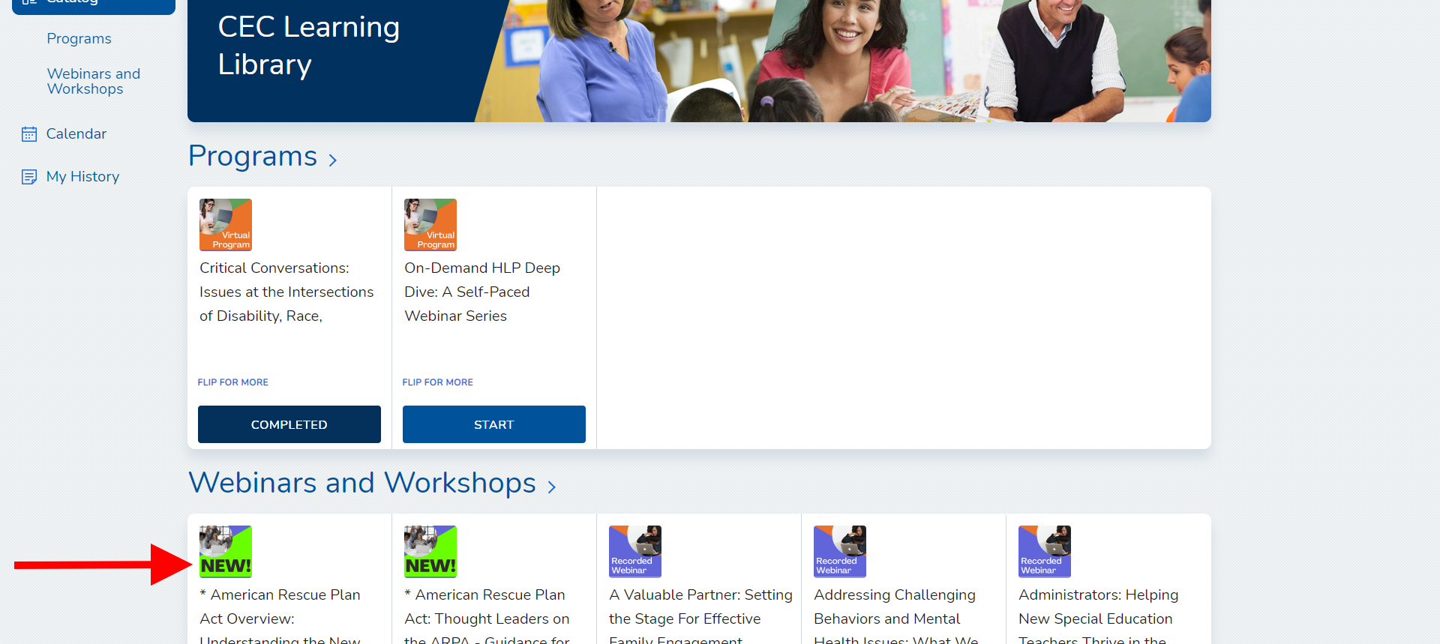

You can find the American Rescue Plan Act webinars under the Webinars & Workshops section in the Catalog.

CEC Members: You have access to the entire library of recorded webinars as part of your member benefits! Just click the “Free” or “Start” button to access the recording.

Viewing and Printing Professional Development Hours Certificates
You can print PDH certificates from the “My History” section. Any webinar or course you have fully completed will show a “Download” arrow for you to access your certificate. You can claim PDHs for any webinar that you have watched the recording of.
Here’s a sample of the “My History” section. You can see the download arrows in the next-to-last column for each webinar, and you can download the certificate for any webinar marked as “Completed.”
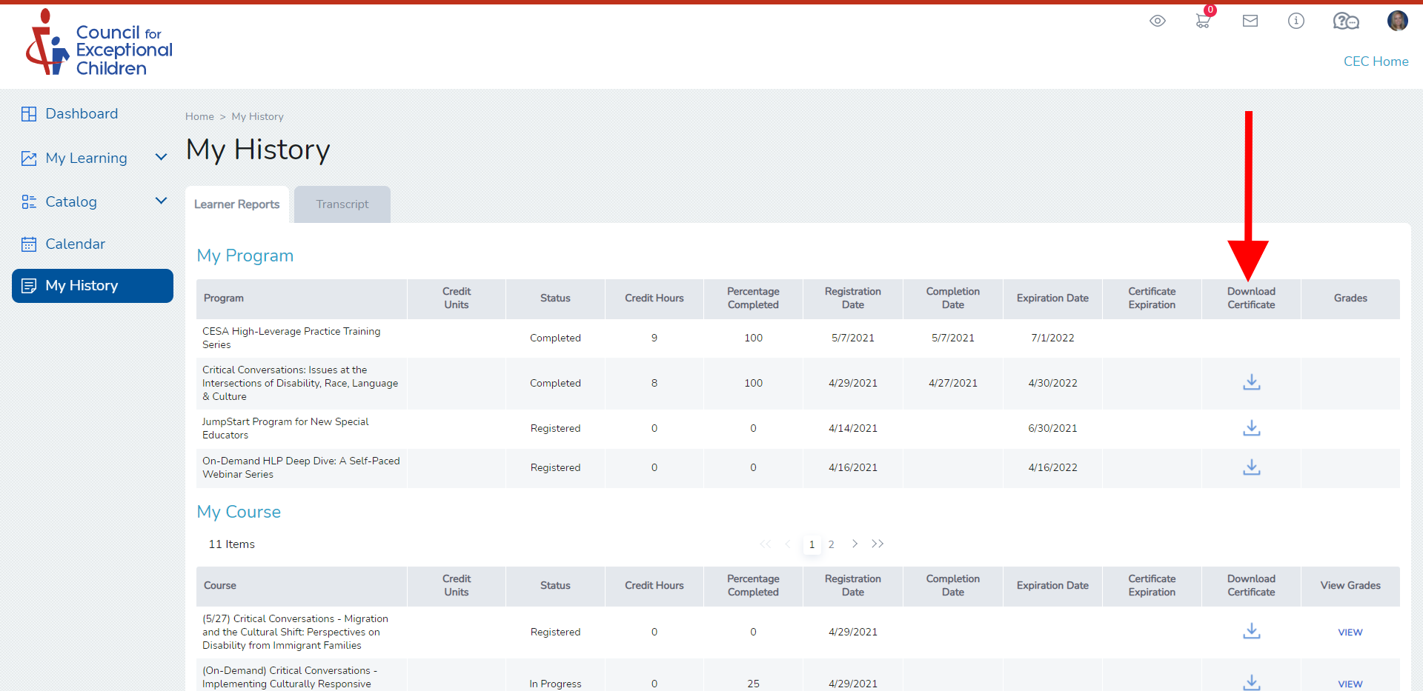

Need help? Have questions? Email us at ceconlinelearning@exceptionalchildren.org.

