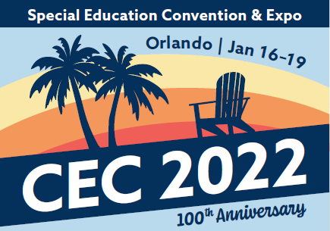
CEC 2022 Submission Guide
Convention Workshop
Thank you for your interest in submitting a workshop proposal. We recommend using the form below to collecting the necessary information before beginning the formal submission process to allow for more time to prepare your responses and avoid any delays in completing your submission.
Workshop submissions will be accepted from April 20, 2021 through May 13, 2021.
By submitting a workshop proposal for CEC 2022, you agree to the following:
- You are submitting a proposal for either a half-day (3-hour) or full-day (6-hour) workshop, to be presented during either/both the in-person component and/or virtual component of CEC 2022. In-person workshops may be half- or full-day sessions, while virtual workshops will be 3-hour sessions.
- You are able to either present your session live during the in-person component of the convention in Orlando, Florida, and/or present your workshop live via Zoom or a similar platform during the virtual component of the convention (currently planned for Feb. 1-4, 2022).
- Due to the high volume of quality submissions, you may be asked if your workshop can be presented in an alternate time frame (as a 3-hour workshop instead of a 6-hour) or in a different format (i.e., virtually instead of in-person)
- Workshops are selected by CEC program staff, with input from the convention program advisory committee. Preference will be given to workshops that include practice- or strategy-based content and align with current or emerging research on best practices (i.e. the HLPs, CEC’s professional standards, etc.).
- CEC will provide a projection package (LCD projector and screen) for in-person workshops. CEC does not provide computer equipment for any convention presentation.
- All lead or co-presenters of workshops that are selected must register for the convention by September 30, 2021. Failure to register by this day will result in cancellation of your session.

We suggest that you prepare all necessary information outlined in the below submission guide before beginning the online submission process. You will be able to cut & paste your responses from this form directly into the online submission form.
Section
2 | Lead presenter information: Name, email, professional organization/affiliation, bio
3 | Co-presenter information (if applicable)
4 | Submission type | x Workshop
5 | Proposed workshop title
5 | Abstract/brief description of workshop (max 100 words)
5 | Rationale and relevance: Describe specific content that will be presented and evidence of effectiveness supporting that content (max 300 words)
5 | Proposed length of workshop | - Half-day workshop (3 hours of content)  May be presented in-person or virtually  - Full-day workshop (6 hours of content)  Presented in-person only
5 | Availability to Present: The CEC 2022 Convention & Expo will be a hybrid event, with content in both virtual and in-person formats. | - Only available to present in-person at CEC 2022 in Orlando,  - Available to present both in-person as well as virtually  - Only available to present virtually
6 | Learner Outcomes: Provide 3 to 4 participant outcomes that describe the skills, knowledge, and/or behaviors participants will know or be able to demonstrate after the session.
7 | Topic areas: Select one primary and one secondary topic area.  See the Workshop Overview, page 2 for a list of topic areas.
7 | Target Audience: Indicate the primary and secondary target audience(s) of your presentation. See the Workshop Overview, page 2 list of target audience types.
7 | Presentation Familiarity Level: New for 2022, please identify the session’s “familiarity level” (select no more than 2) | - Introductory – intended for those not familiar or vaguely familiar with the topic  - Intermediate – intended for those somewhat or relatively familiar with the topic  - Advanced – intended for those already very familiar with the topic
7 | Which, if any, of the High-Leverage Practices does your workshop align with? | - Collaboration  - Assessment  - Social/Emotional/Behavioral  - Instruction
8 | Previous presentations: Relevant history on past presentations of this content

The deadline to submit a workshop proposal is 11:45 PM Eastern on Thursday, May 13, 2021.
Questions? Contact PD@exceptionalchildren.org.

