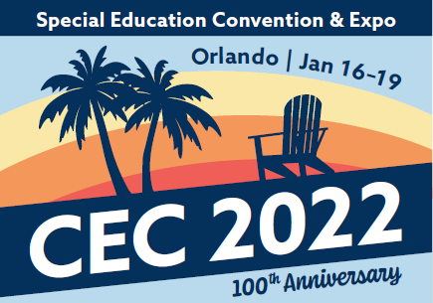
CEC 2022 Submission Guide
Research-to-Practice Deep Dive Sessions
Thank you for your interest in submitting a research-to-practice deep dive session proposal. We recommend using the form below to collecting the necessary information before beginning the formal submission process to allow for more time to prepare your responses and avoid any delays in completing your submission.
Research-to-Practice Deep Dive submissions will be accepted from April 20, 2021 through May 13, 2021.
By submitting a deep dive proposal for CEC 2022, you agree to the following:
- You are able to present the full 90-minute deep dive session live during the in-person component of the convention in Orlando, Florida, as well as record the 45-minute “research” portion as of the session yourself for a virtual format. There is an embargo period and recordings cannot be shared until after March 13, 2022.
- Deep Dives are selected by CEC program staff, with input from the convention program advisory committee. Preference will be given to workshops that include practice- or strategy-based content and align with current or emerging research on best practices (i.e. the HLPs, CEC’s professional standards, etc.).
- CEC will provide a projection package (LCD projector and screen) for in-person sessions. CEC does not provide computer equipment for any convention presentation.
- All lead or co-presenters of sessions must register for the convention by September 30, 2021. Failure to register by this day will result in cancellation of your session.

We suggest that you prepare all necessary information outlined in the below submission guide before beginning. You will be able to cut & paste your responses from this form directly into the online submission form.
Section
2 | Lead presenter information: Name, email, professional organization/affiliation, bio
3 | Co-presenter information (if applicable): Name, email, professional affiliation
4 | Submission type | Research-to-practice deep dive
5 | Proposed session title (max 12 words)
5 | Abstract/brief description of session (max 100 words)
5 | Rationale and relevance to the field of special education (max 200 words)
5 | Describe the specific content that will be presented during the “research” segment of the session and evidence of effectiveness supporting that content (up to 200 words)
5 | Describe the activity/practice learning opportunity/format of the interactive or “practice” segment of the session (up to 200 words)
5 | Would your session necessitate limiting the number of attendees for the interactive/practice portion? | - No  - Yes (please specify maximum number of participants)
5 | Would you need a specific room setup/configuration for your session? | - No  - Yes (please describe)
6 | Learner Outcomes: Provide 3 to 4 participant outcomes that describe the skills, knowledge, and/or behaviors participants will know or be able to demonstrate after the session. At least one of these outcomes should relate to the research portion of your session, and at least one should relate to the interactive portion of your session.
7 | Topic areas: Select one primary and one secondary topic area.  See the Deep Dive Overview, page 2 for a list of topic areas.
7 | Target Audience: Indicate the primary and secondary target audience(s) of your presentation. See the Deep Dive Overview, page 2 for a list of target audience types.
7 | Presentation Familiarity Level: New for 2022, please identify the session’s “familiarity level” (select no more than 2) | - Introductory – intended for those not familiar or vaguely familiar with the topic  - Intermediate – intended for those somewhat or relatively familiar with the topic  - Advanced – intended for those already very familiar with the topic
7 | Which, if any, of the High-Leverage Practices does your session align with? | - Collaboration  - Assessment  - Social/Emotional/Behavioral  - Instruction
8 | Previous presentations: Relevant history on past presentations of this content

The deadline to submit a workshop proposal is 11:45 PM Eastern on Thursday, May 13, 2021.
Questions? Contact PD@exceptionalchildren.org.

