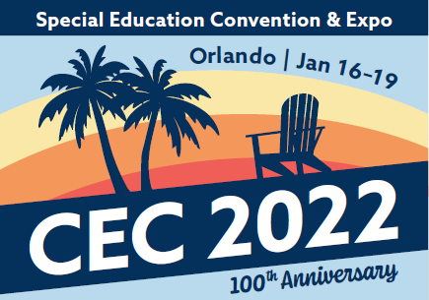
CEC 2022 Submission Guide
Concurrent, Multi-Presentation, Poster, and Data Blitz Sessions
Thank you for your interest in submitting proposal for the CEC 2022 Convention & Expo!. We recommend using the form below to collecting the necessary information before beginning the formal submission process to allow for more time to prepare your responses and avoid any delays in completing your submission.
Submissions will be accepted from April 20, 2021 through May 20, 2021.
By submitting a proposal for CEC 2022, you agree to the following:
- As a session leader you may submit TWO presentations. You may also be listed as a co-presenter on TWO presentations (a total of four listings). If you are involved in multiple presentations, you are required to present at all sessions.
- All lead or co-presenters of sessions must register for the convention by September 30, 2021. Failure to register by this day will result in cancellation of your session.
- You are able to either present your session in-person as well as record the session yourself for a virtual format, or that you are able to record the session yourself for presentation in a virtual format only. There is an embargo period and recordings cannot be shared until after March 13, 2022. This will allow CEC Convention & Expo registered attendees to have access first. Presenters are welcome to share their recorded presentations publicly after March 13, 2022.
- CEC will provide a projection package (LCD projector and screen) for concurrent sessions, multi-presentation sessions, and data blitz sessions. In-person poster sessions will not have any AV equipment provided. It is your responsibility to bring your laptop or arrange to rent equipment. CEC does not provide computer equipment for any convention presentation.

Section
1 | Title of presentation (max 12 words)
1 | Session format (select one) | - Concurrent Session  - Multi-Presentation Session  - Poster Session  - Data Blitz
1 | Category of evidence (select one)  See the full Call, page __ for more information on evidence types. | - Practitioner Evidence  - Research from quantitative, qualitative, or mixed methods  - Policy
2 | Lead presenter information
2 | Co-presenter information (if applicable)
3 | Abstract: Brief summary of the session (max 50 words)
4 | Description: Organized in terms of the below four selection criteria (max 500 words). See the full Call for more information regarding each of the selection criteria.  - Rationale for presentation  - Usefulness to Practitioners  - Relevance to Learners, Families, and/or Educators of Diverse Groups  - Evidence of the Effectiveness
5 | Learning Outcomes: Provide 2 to 3 participant outcomes that describe the skills, knowledge, and/or behaviors participants will know or be able to demonstrate after the session.
6 | Topic areas: Select one primary and one secondary topic area.  See the full Call, page ___ for the complete list of topic areas.
7 | Alternate session format: Are you willing to accept an alternate format from the preferred session format indicated in section 1? | - Yes  - No
7 | Availability to Present: The CEC 2022 Convention & Expo will be a hybrid event, with content in both virtual and in-person formats. | - I am available to present my session in-person at CEC 2022 in Orlando, Jan. 16-19, as well as record my session for a virtual format  - I am only available to record my session for a virtual format and will not be able to present in-person
7 | Presentation Familiarity Level: New for 2022, please identify the session’s “familiarity level” (select no more than 2) | - Introductory – intended for those not familiar or vaguely familiar with the topic  - Intermediate – intended for those somewhat or relatively familiar with the topic  - Advanced – intended for those already very familiar with the topic
7 | Target Audience: Indicate the primary and secondary target audience(s) of your presentation. See the full Call, page ___ for the full list of target audience types.

Before you submit your proposal, section 9 will verify that your electronic signature confirms:
- If your proposal is based on your dissertation, you have read and understand the expectations about presentations based on dissertation research.
- Your commitment to register for the convention by September 30, 2021 if your proposal is accepted or you are a co-presenter on another proposal.
- Your proposal does not promote commercially available products, services, or programs.

The deadline to submit a proposal is 11:45 PM Eastern on Thursday, May 20, 2021.
Questions? Contact convproposals@exceptionalchildren.org.

